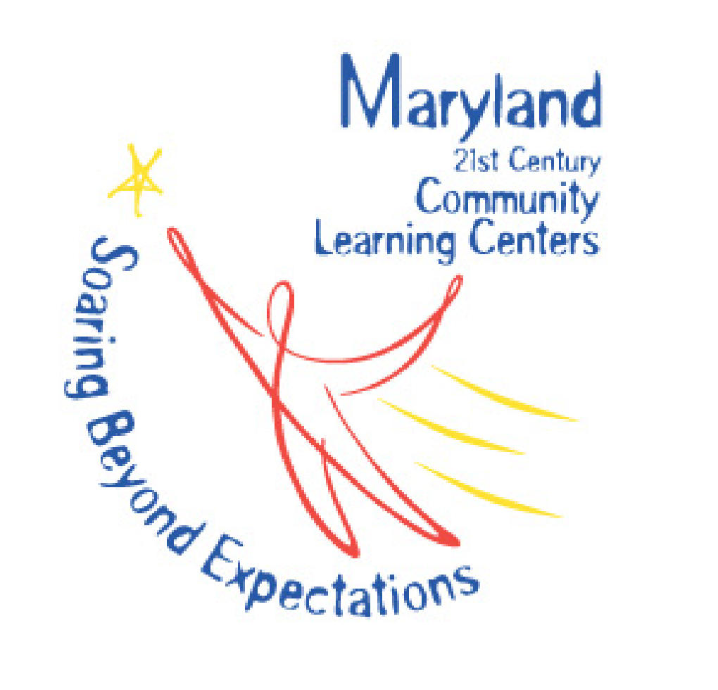
HOPE AFTER SCHOOL PROGRAM
Application for Employment
Enrichment Team
The Hope After School Program is a project made possible by a grant from the Maryland State Department of Education and the 21st Century Community Learning Center program.
Name: | Email:
Cell phone: | Home phone:
Address:

Position you are applying for:

What excites you about the opportunity to work at the Hope After School Program?

Education: Please list all degrees, certifications, and training which would be relevant for your position.

What professional or personal/volunteer experience do you have working in an educational or child care setting?

What professional or personal/volunteer experience do you have in the area of athletics, physical fitness, nutrition, meditation, or stress management?

What professional or personal/volunteer experience do you have in the arts? (visual arts, crafts, drama, music, engineering, building, dance, technology)

Professional Experience: Please list all experiences which would be relevant for your position.

Please include the name, position title, phone, and address of at least one professional reference.

Personal Experience: Please list any additional experience which you feel prepares you for the desired position.

Personal Reference: Please provide the name, phone, and address of one individual who can speak to your character and how you relate to children.

What skills and abilities do you have, in addition to what has already been shared, which will make you a top candidate for your desired position.

Willing to submit to “Child Care Full Background” including fingerprint transaction completed by Maryland Department of Public Safety and Correctional Services.

YES / NO

Please fill out the attached Employment History Review Form.
Child Sexual Abuse and Sexual Misconduct
Pursuant to Section 6-113.2 of the Education Article, Annotated Code of Maryland

